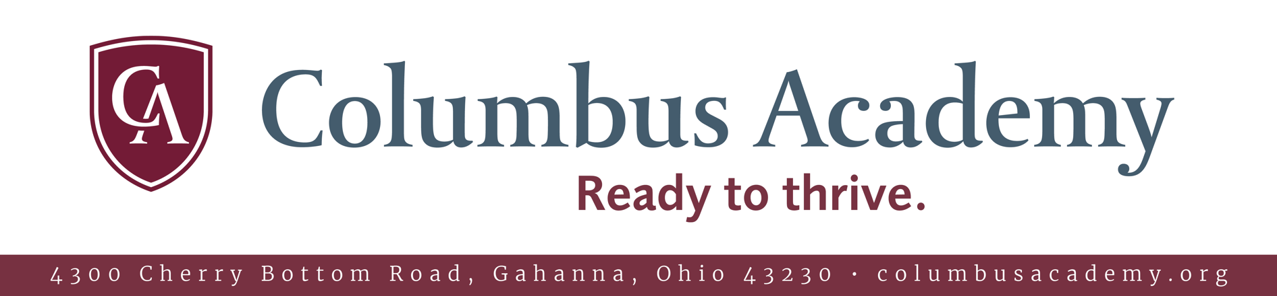

Our Mission
Columbus Academy – an independent, coeducational college preparatory school – enriches its academic tradition of excellence by valuing a broad diversity of students as it seeks to develop the complete person: mind, body and character. The school rewards rigorous effort and accomplishment, fosters compassion, respect and moral courage, and insists on integrity, fair play and community service. Academy strives to develop and sustain a community of thoughtful, responsible, capable and confident citizens eager to engage in a pluralistic and ever-changing world.

At a Glance
Founded: 1911
Enrollment: 1,162 students
Ages: 3YO-Grade 12
Students of Color: 48%
Total Tuition Assistance: $4.8M

Quality of Life in Columbus
Columbus is the 14th largest city in the United States with a population of 879,170. The city
is perfect for active lifestyles, having invested $20 million to develop a growing system of bike and fitness trails that connect the suburbs and river trails to downtown’s $44 million riverfront park system restoration. Columbus is gaining nationwide recognition for its historic neighborhoods, booming downtown arts and sporting districts, open attitude and
a noticeably affordable quality of life.
Check out our Guide to Columbus!

Accountant
Start date: July 7, 2025 • Apply online at columbusacademy.org/apply

About Columbus Academy
Recognized as a premier independent school in the nation, Columbus Academy has, since its founding in 1911, exemplified the country day school educational model. The heart of this model is the idea that the best interests of children are served when home and school work together.

At Columbus Academy, parents are integral members of our community. In our welcoming school, fully dedicated to the development of young scholars, athletes and artists of every kind, parents find what they are looking for: The school to trust with childhood.

We believe that diversity, inclusion, equity and justice are essential measures of our excellence. Our goal is not to mold young minds but to light them on fire.

Visit us and you will see this in the way we teach and the way our 231-acre campus is designed — the light, the energy and the interconnectedness of our mindfully designed learning spaces that allow for children to gaze out to the
open sky.


Position Description
Columbus Academy seeks a full-time Accountant with responsibilities to begin July 7, 2025. This is a year-round position with regular hours of 8:00 a.m. to 4:30 p.m. Monday through Friday. There are four weeks of paid vacation between the months of September and June which are to be taken at a time approved by the Controller.

The individual selected for this position will be expected to carry out the following responsibilities:

General Ledger
- Prepare and data enter fixed asset forms, balance monthly the fixed asset subsystem to the G/L
- Handle all aspects of fixed assets including coding of invoices, depreciation processing, and reporting
- Conduct fixed asset physical inventory as needed
- Generate and enter biweekly payroll journal entries and other entries as assigned
- Prepare retirement worksheets for general ledger entry
- Assist with external audit tasks like worksheet generation, document scanning and copying, and booking prepaid expense
Reports
- Complete Unclaimed Funds letters and report for review by Controller
- Help with surveys including, but not limited to, those of NAIS and OAIS
- Assist with preparation of endowment reports

HR Related Functions
- Van driver certification processing and records maintenance
- Conduct criminal background checks for employees and contracted service providers in the absence of the Human Resources Manager

General
- Assist with receipts processing including; but not limited to, tuition, enrollment deposits, and summer camp registrations
- Generate and enter all camp transactions for the Summer Experience program
- Prepare purchase orders and maintain purchase order records
- Serve as back-up for accounts payable processing
- Assist with petty cash disbursement and balancing
- Function as a Business Office receptionist to serve parents, colleagues, students and other visitors
- File and/or scan documents including invoices / checks, purchase orders, journal entries, and fixed assets back-up
- Assist the Chief Financial Officer and the Controller as needed, including with Board related matters, meeting preparation, information collection, and other assigned tasks.

Qualifications
Preferred candidates will possess the following qualifications:

- A minimum of a bachelor’s degree in accounting
- A minimum of five years of related experience including in accounts payable, fixed assets, and payroll
- The ability to work with detailed, numerical data with a high level of accuracy
- Computer skills including Excel spreadsheet, Microsoft Word, and ADP payroll
- Organization and multitasking skills
- A reflective practitioner, committed to a continuous process of self-improvement and lifelong learning
- Ability to collaborate with others and to creatively solve problems
- Enthusiasm, a positive sense of humor, self-confidence, and effective oral and written communication skills

Physical Conditions
Candidates must be able to manage the following conditions:

- A fast-paced office environment requiring a high level of accuracy, a commitment to outstanding service, and the ability to effectively multitask
- Occasional additional hours as needed to meet required deadlines
- A non-smoking environment

Columbus Academy believes strongly in the principles of diversity, equity, inclusion and belonging. We strive to foster a diverse campus community, which recognizes the value of all persons regardless of religion, race, ethnicity, gender, sexual
orientation, disability or socioeconomic background.

Legal requirements: All Columbus Academy employees must pass required criminal records checks. Where appropriate, individuals

will also be required to provide proof of academic credentials.

