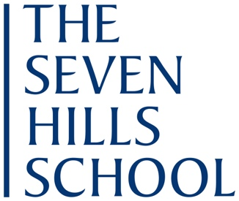

Middle School Mathematics Teacher (Part Time)

The Seven Hills School seeks a part-time Middle School Math Teacher. The position involves teaching two sections of seventh-grade or eighth-grade math with an average class size of 16.

We would prefer candidates who have a degree in the field and experience teaching middle school students. Candidates should work well with colleagues, have strong organizational skills and habits, and possess a sense of humor and of creativity.

An equal opportunity employer, Seven Hills encourages candidates with diverse backgrounds to apply for this position. Candidates should apply by clicking here. Full applications should include letter of interest, resume, transcripts, and letters of recommendation.

