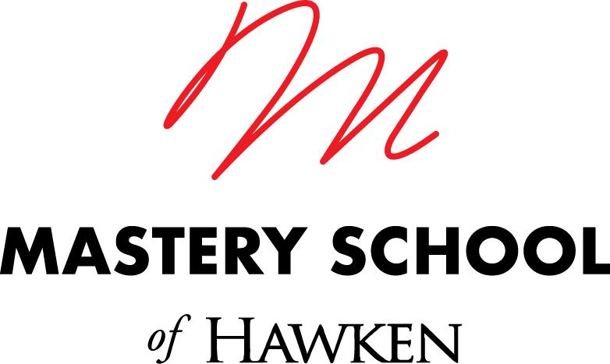

Director of College Counseling
Mastery School of Hawken

A Bit About Us

Hawken School is a preschool-12 co-ed independent day school with four campuses in Cleveland Ohio and founder of the Mastery Transcript Consortium, a national organization aimed at reinventing how students prepare for college, careers, and life. In August 2020, we launched the Mastery School of Hawken, a new project- and problem-based ungraded high school in the University Circle neighborhood of Cleveland. We will graduate our first class of seniors in June of 2023.

The Challenge

We’re designing the The Mastery School of Hawken around three core principles:
- Learning experiences are organized around real-world problem-solving, where students learn while working on challenges with community partners.
- We use new methods of teaching designed around individual growth, allowing for more project-based and personalized learning.
- Our mastery assessment model emphasizes feedback for growth and credits enduring, deep, and transferable learning using mastery credits.

Committed to strengthening our relationship to our city, we are building this school for greater socioeconomic access by offering a significant number of seats to full-need students from the city of Cleveland. Read more about us here: http://masteryschool.hawken.edu.

The Opportunity

We are seeking a dynamic, curious, knowledgeable and collaborative individual to join the team at the Mastery School of Hawken on the University Circle campus. As part of the core team of the Mastery School, you’ll get to know students and families and will work closely with them throughout their time to guide and support the college admission process. You will serve as a translator and storyteller for students’ learning and growth in a mastery-based, community-facing, problem and project-based learning school. You will also serve as a public-facing professional in the college admission counseling community by educating college admission counselors about mastery learning and the mastery transcript.

The Skillset

About You:
- Wildly enthusiastic about mentoring and coaching adolescents
- Skilled communicator, listener, and relationship-builder who enjoys working in a highly collaborative environment
- Significant depth of expertise in College Counseling and/or holistic and innovative college admissions work (5+ years)
- Able to write personal and persuasive narrative recommendation letters for students
- Skilled at guiding students through the reflection and writing process for college applications
- Able to guide projects to completion and to catch details both large and small
- Skilled at juggling and prioritizing multiple tasks
- Intellectually curious, self-directed, and motivated learner with a wide range of interests and skills, academic and otherwise
- Skilled and committed to active, ongoing development of your cultural competence
- Philosophically aligned with the mission of the Mastery School of Hawken
- Able to operate in ambiguity, roll up your sleeves and jump in to do what the team needs
- The following skills are a major plus:
  - Experience teaching test prep
  - Experience in creative problem-solving and building things (organizations, businesses, products, teams)

The Team

As a member of the Mastery School team, you’ll collaborate closely with colleagues as we continue to build a high school program designed to maximize the individual growth of every student. With support and guidance from the Upper School College Counseling office, you’ll help students and families navigate the college process. As part of a founding school for the Mastery Transcript Consortium (MTC), you’ll have support from the MTC, a non-profit with an international membership of 400+ schools. Together, we’ll create a high school that provides a new model for education.

The Journey

Within one month, you’ll:
- Meet and begin to learn about our rising seniors and their families
- Learn from the Upper School College Counseling team about practices and curriculum they use to support students in the college process
- Access professional learning networks including the Mastery Transcript Consortium and networks of independent school college counselors for training and support
- Learn about your new colleagues on the Mastery School team and their work
- Learn how our model of teaching & learning works by participating in on-demand training through the Korda Institute for Teaching (http://kordainstitute.org)

Within three months, you’ll:
- Meet regularly with 12th-grade students and their parents as they go through the college application process
- Host college representatives on campus in person or virtually
- Assist students in preparing their transcripts
- Take responsibility for advising one group of students as their Wayfinding mentor (with support from a co-mentor)
- Design and lead ongoing support for 12th graders through College Forum in partnership with the Wayfinding program
- Facilitate on-campus and virtual test prep built into the school day
- Coordinate the process of applying for learning accommodations for standardized testing
- Read and provide feedback on college essays and supplemental application questions
- As a member of the administrative team of the Mastery School, support the implementation of the academic and non-academic program as needed

Within six months, you’ll:
- Get to know our academic program and what student growth and success looks like by attending student presentations of learning
- Compose compelling school letters of recommendation for each senior advisee (eventual load is around 40 students)
- Plan and conduct college information programs regarding college admission, office procedures, financial aid, etc. for current 10th, 11th and 12th-grade families
- Participate actively in admissions work for the Mastery School, engaging with prospective families around mastery learning and the college process
- Coordinate the administration of the PSAT on our campus and serve as site coordinator for the College Board
- Engage and reflect with colleagues on an ongoing basis about your learning, growth, and development
- Educate college representatives about the Mastery Transcript and connect them with further resources

Within the first year you’ll:
- Create and maintain strong professional ties with college admission officers
- Attend national and regional conferences, college tours, and local college events
- Support academic advising of sophomore students in the spring semester
- Partner with the Mastery Transcript Consortium team on outreach to colleges and universities about the Mastery Transcript
- Lead the design for how the college counseling process at the Mastery School can work in partnership with Wayfinding and this distinctive academic program
- Assist or manage special projects such as communications calendar, scholarship database, website upgrades, social media, and college fair/case study events

Anticipated start date: Spring/Summer 2023.

INTERESTED?
Please send a resume, a list of references (at least one from a current employer), and a cover letter to: mshemployment@hawken.edu .

Hawken School is an equal opportunity employer dedicated to promoting all forms of diversity in the workplace and in our student body. We strongly urge all qualified individuals to apply.

