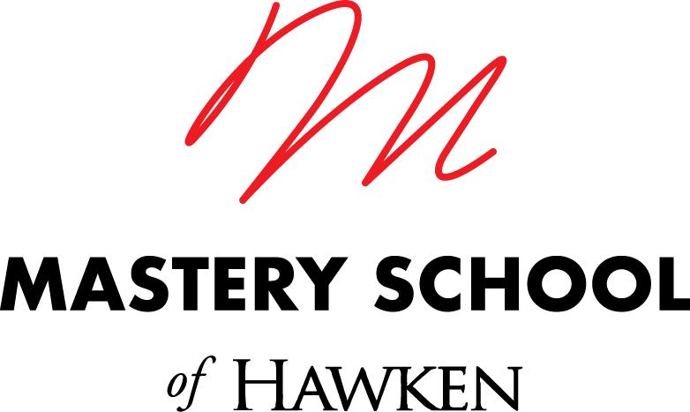

Faculty – Life Sciences
Mastery School of Hawken

The Opportunity

We are seeking a dynamic, curious, collaborative individual to join the faculty of the Mastery School of Hawken for the 2023-24 school year. At the heart of our model is the idea that you learn while doing – so you’ll get coaching and support as you learn how to teach in a very different way at our ungraded, project and problem-based high school.

About You:
- Wildly enthusiastic about mentoring and coaching adolescents
- Experienced in creative problem-solving and building things in the real world
- Skilled communicator and listener who enjoys working in a highly collaborative environment
- Intellectually curious, self-directed and motivated learner with a wide range of interests and skills, academic and otherwise
- Committed to active, ongoing development of intercultural competence
- Philosophically aligned with the mission of the Mastery School of Hawken
- Able to operate in ambiguity and roll up your sleeves and jump in to do what the team needs
- Significant depth of expertise and professional experience in Life Sciences, such as Neuroscience, Environmental Science, or Public Health
- Experience in one of the following additional areas is a plus:
  - Chemistry
  - Computational Thinking and Coding
  - Entrepreneurship
  - Math and Data Analytics
  - Spanish
  - Visual and/or Performing Arts

About Us

Hawken School is a preschool-12 co-ed independent day school with four campuses in Cleveland Ohio and founder of the Mastery Transcript Consortium, a national organization aimed at reinventing how students prepare for college, careers, and life. In August 2020, we launched the Mastery School of Hawken, a new project- and problem-based ungraded high school in the University Circle neighborhood of Cleveland. We will graduate our first class of seniors in June of 2023.

We’ve designed the The Mastery School of Hawken around three core principles:

- Learning experiences are organized around real-world problem-solving, where students learn while working on challenges with community partners.
- We use new methods of teaching designed around individual growth, allowing for more project-based and personalized learning.
- Our mastery assessment model emphasizes feedback for growth and credits enduring, deep, and transferable learning using mastery credits.

Committed to strengthening our relationship to our city, we are building this school for greater socioeconomic access by offering a significant number of seats to full-need students from the city of Cleveland. Read more about us here: http://masteryschool.hawken.edu.

The Team

You’ll join our dynamic team of educators as we enter Year 4 of the school. As you onboard and learn our methods and approaches, you’ll take increasing responsibility for program elements over your first year. You’ll also bring your unique set of strengths to all aspects of school life, in the classroom, in our Wayfinding program, and in co-curriculars. Together, we’ll create a high school that provides a new model for education. While experience working with young people is vital, classroom experience is not a necessity and career-changers are welcome!

The Journey

Within one month, you’ll:
Learn how our model of teaching & learning works by participating in on demand training through the Korda Institute for Teaching (http://kordainstitute.org)
Participate in an all-school onboarding experience designed to connect you to colleagues across Hawken and our city
Engage in a Mastery-School specific onboarding experience
Gain hands-on training to support your work in counseling and advising students

Within three months, you’ll:
Design and teach learning experiences in our macros and/or micros
Build initial connections with key community partners
Take leadership of one or more co-curricular offerings for students
Collaborate closely with colleagues on all aspects of year 4 program implementation, jumping in to help as needed
Engage in biweekly new faculty support sessions designed to be responsive to what you’ll likely experience in your first few months

Within the first six months, you’ll:
Plan and implement your first pilot as a lead using the Korda Institute’s teaching methods
Engage and reflect with colleagues on an ongoing basis about your learning, growth, and development
Refine your instructional practice with ongoing coaching from the Korda Institute for Teaching, the Director of the Mastery School and collaboration with peers
Begin to design and plan to take on a lead designer role in year 5 macros and/or micros as the school continues to scale

This position will require training in summer 2023 with a full time start in August 2023.

INTERESTED?
Please send a resume, references, and a cover letter to: mshemployment@hawken.edu .

Hawken School is an equal opportunity employer dedicated to promoting all forms of diversity in the workplace and in our student body. We strongly urge all qualified individuals to apply.

